双流某重点小学二年级上学期英语期末试题
听力部分（30分）
一、听录音，给下列图片排序，将序号写在横线上。（10分）
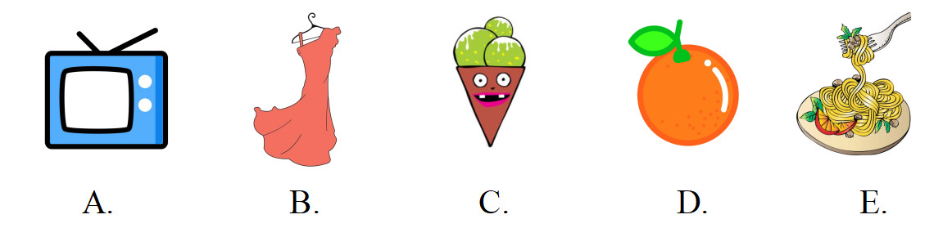
_______________________________
二、听录音，在横线上写下你听到的单词。（10分）
1. Come on, ______ A.
2. These ______ are for you.
3. Welcome to my _______.
4. This car is ______ small.
5. ______ are our future.

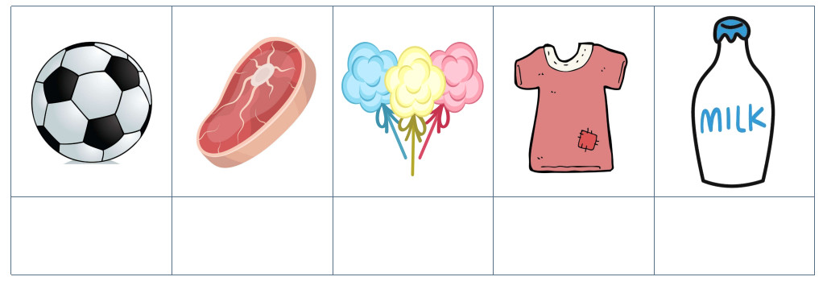

笔试部分（70分）
四、按照字母表的顺序默写26个英文字母的大小写。（10分）
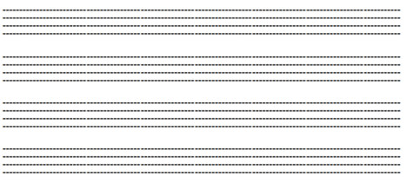
五、选出与其他单词不是同一种类的选项。（10分）
（ ）1. A. ginger B. onion C. apple
（ ）2. A. their B. my C. him
（ ）3. A. have B. T-shirt C. trousers
（ ）4. A. lunch B. tomato C. dinner
（ ）5. A. song B. sing C. watch
六、找出错误，并在直线上改正。（10分）
1. This are my trousers.
错误是_________，应改为_________
2. I play football on 5.
错误是_________，应改为_________
3. Lily, here is gifts for you.
错误是_________，应改为_________
4. Binbin like red shoes.
错误是_________，应改为_________
5. This is she dress.
错误是_________，应改为_________
七、单项选择。（10分）
（ ）1. _____ favourite song is Twinkle Twinkle Little Star.
A. My B. He C. They
（ ）2. Let’s _____ my bike.
A. to ride B. riding C. ride
（ ）3. －Do you like milk?
－________
A. Yes, I don’t. B. No, I am. C. Yes, I do.
（ ）4. Look ____ this photo.
A. at B. on C. with
（ ）5. Judy ______ blue dress.
A. like B. doesn’t like C. don’t like
八、英汉互译。（10分）
1. Linda likes noodles.

2. 你喜欢洋葱吗？

3. Pigs like everything.

4. 糖果是给好孩子的。

5. ABC song is my favourite song.

九、写作训练。用一句话来描述所给的图片。（20分）
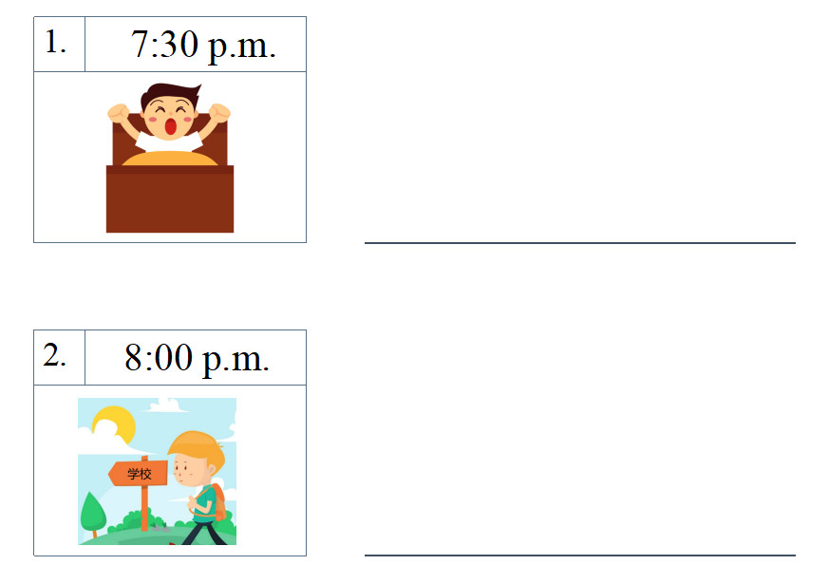
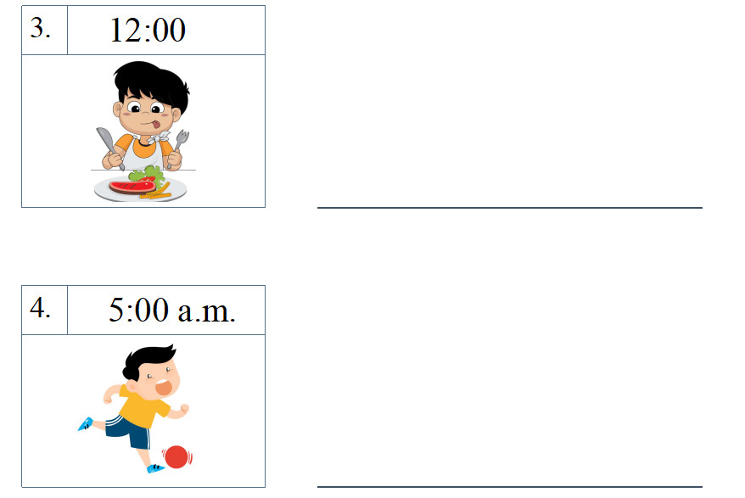
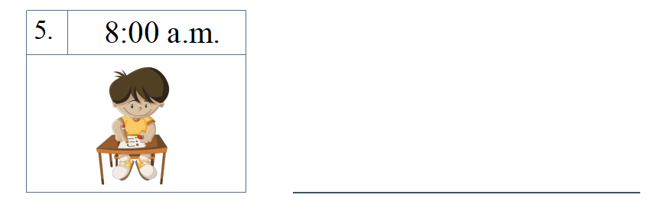

参考答案

听力材料
一、听录音，给下列图片排序，将序号写在横线上。每小题读一遍。
1. noodles 2. TV 3. orange 4. ice cream 5. dress
二、听录音，在横线上写下你听到的单词。每小题读两遍。
1. Come on, team A.
2. These tomatoes are for you.
3. Welcome to my party.
4. This car is too small.
5. Children are our future.

1. I like football.
2. Bob doesn’t like meat.
3. Linda likes sweets very much.
4. Judy doesn’t like that old T-shirt.
5. Jack likes milk.
一、1-5 EADCB
二、1. team 2. tomatoes 3. party 4. too 5. Children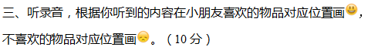
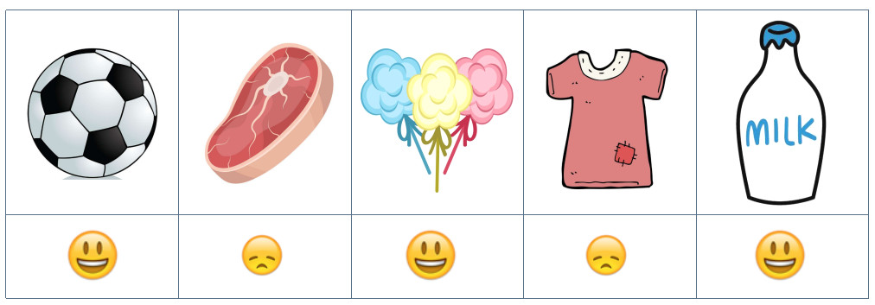

四、
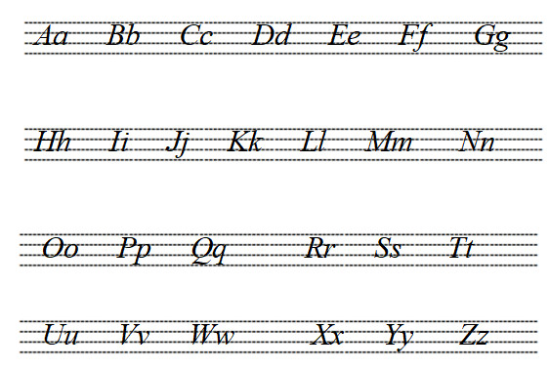
五、1-5 CCABA
六、1. This; These 2. on; at 3. gifts; a gift 4. like; likes 5. she; her
七、1-5 ACCAB
八、1. 琳达喜欢面条。
2. Do you like onions?
3. 小猪们喜欢所有东西。
4. Sweets are for good boys.
5. 字母歌是我最喜欢的歌。
九、1. I get up at 7:30 in the morning.
2. I go to school at 8:00 in the morning.
3. I have lunch at 12:00.
4. I play football at 5:00 in the afternoon.
5. I do my homework at 8:00 in the evening.

- END -

